30 FT. COMMERCIAL PANEL TREE OCT, 2022

Assembly Procedure:
- Layer U2
- Screw up 1 pieces of layer U2 metal frames to form this layer

- Layer U3
- Screw up 3 pieces of layer U3 metal frames to form this layer

- Layer U4
- Screw up 3 pieces of layer U4 metal frames to form this layer

- Layer U5
- Screw up 6 pieces of layer U5 metal frames to form this layer

- Layer U6
- Screw up 6 pieces of layer U6 metal frames to form this layer

- Layer U7
      - Screw up 6 pieces of layer U7 metal frames to form this layer

- Layer U8
      - Screw up 6 pieces of layer U8 metal frames to form this layer

- Layer U9
      - Screw up 9 pieces of layer U9 metal frames to form this layer
- Tree Top
- Insert the tree top into the central socket of layer U2

- Shape the Branch

- Install the 217 sets of branch panels in to hob
  - Layer U2: Install 7 sets of branch panels w/LED
  - Layer U3: Install 12 sets of branch panels w/LED
  - Layer U4 : Install 18 sets of branch panels w/LED
  - Layer U5 : Install 24 sets of branch panels w/LED
  - Layer U6 : Install 30 sets of branch panels w/LED
  - Layer U7: Install 36 sets of branch panels w/LED
  - Layer U8: Install 42 sets of branch panels w/LED
  - Layer U9: Install 48 sets of branch panels w/LED

- Connect the LED each branch panels on each Level

- Every set of extension cord for each item was packed in a small plastic bag. The installation will depend on the number and type of lights on the tree, where the tree is placed in proximity to the power source, and the type of power source itself. Please consult an electrician regarding these issues.

- Maximum connection of 45 sets of warm white C7 LED together

30 FT. COMMERCIAL PANEL TREE
Tree Top

45cm Dia

90cm Dia
1st Layer

^{2nd} Layer
135 cm Dia.

180 cm Dia
3rd Layer
225cm Dia.
315cm Dia.
360 cm Dia.
270cm Dia.
405 cm Dia.

^{8th} Layer
^{4th} Layer
^{7th} Layer
^{6th} Layer
^{5th} Layer

Top View of U9 Layer
Layer U9 is divided into 9 pieces,

Lower Diameter is 405cm
Upper Diameter is 360cm

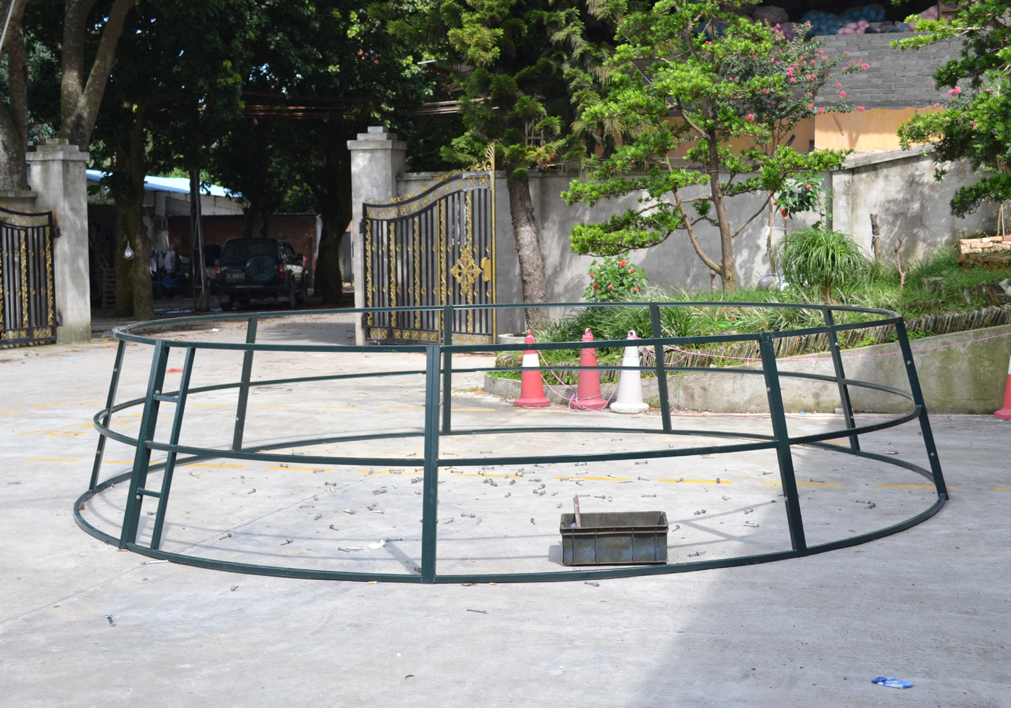

Screw up the metal frames to form this layer
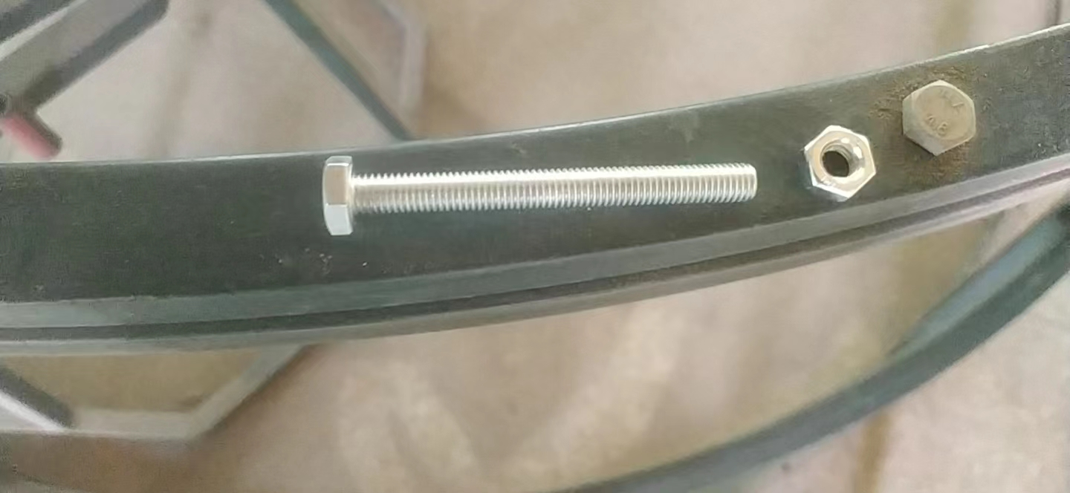
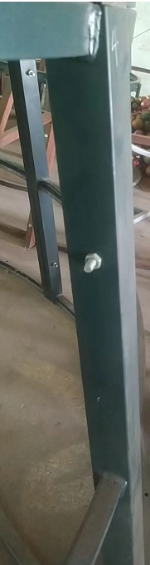

Top View of U5^{th-}8th Layer
Each layer is divided into 6 pieces, screw up the metal frames to form this layer

Lower Diameter is 360 cm on U8 layer
Upper Diameter is 315cm on U8 layer
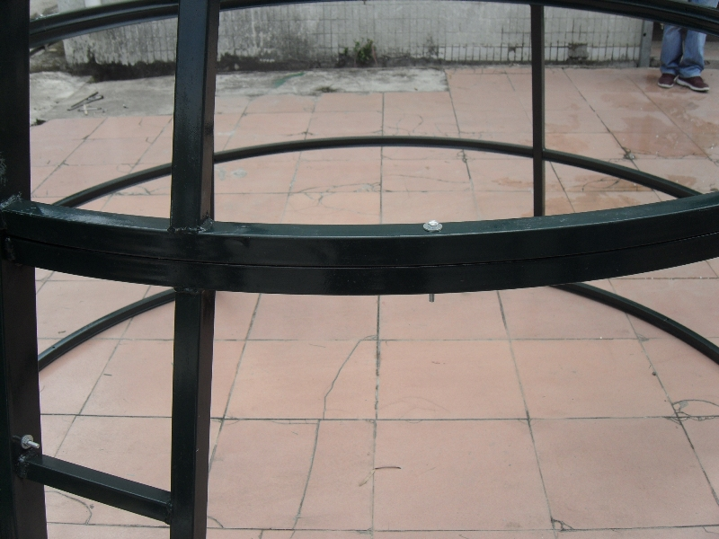
Screw up Layer U8 and Layer U9
Make sure the ladder is built in the same position on each layer to connect them from bottom to top
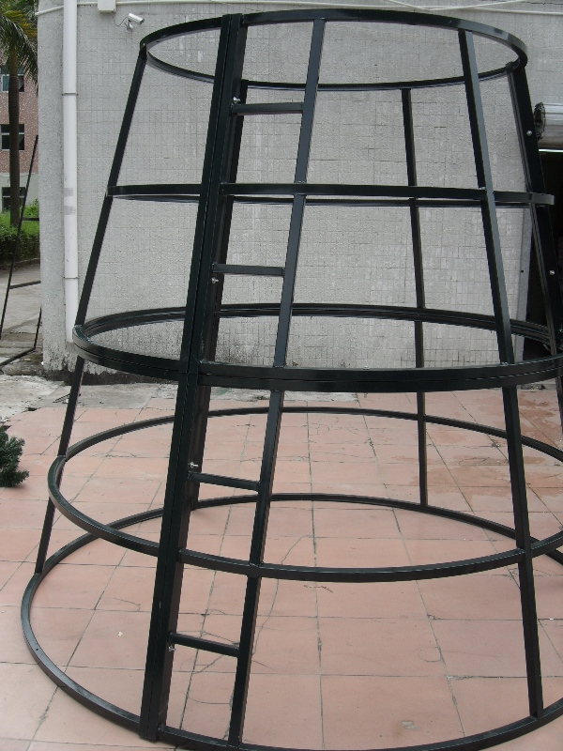

Top View of U3-U4 Layer
- Each Layer is divided into 3 pieces; screw up the metal frames to form this layer
- Screw up Layer U4 and Layer U3 , and Make sure the ladder is built in the same position on each layer to connect them from bottom to top
Lower Diameter is 135cm on U4 layer
Upper Diameter is 90cm on U3 layer

^{1st} Layout:
Layer U2 is divided into 1 piece, and screw up layer U2 and layer U3 metal frames

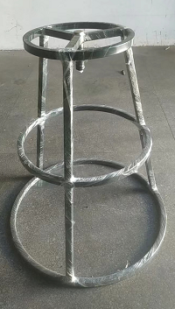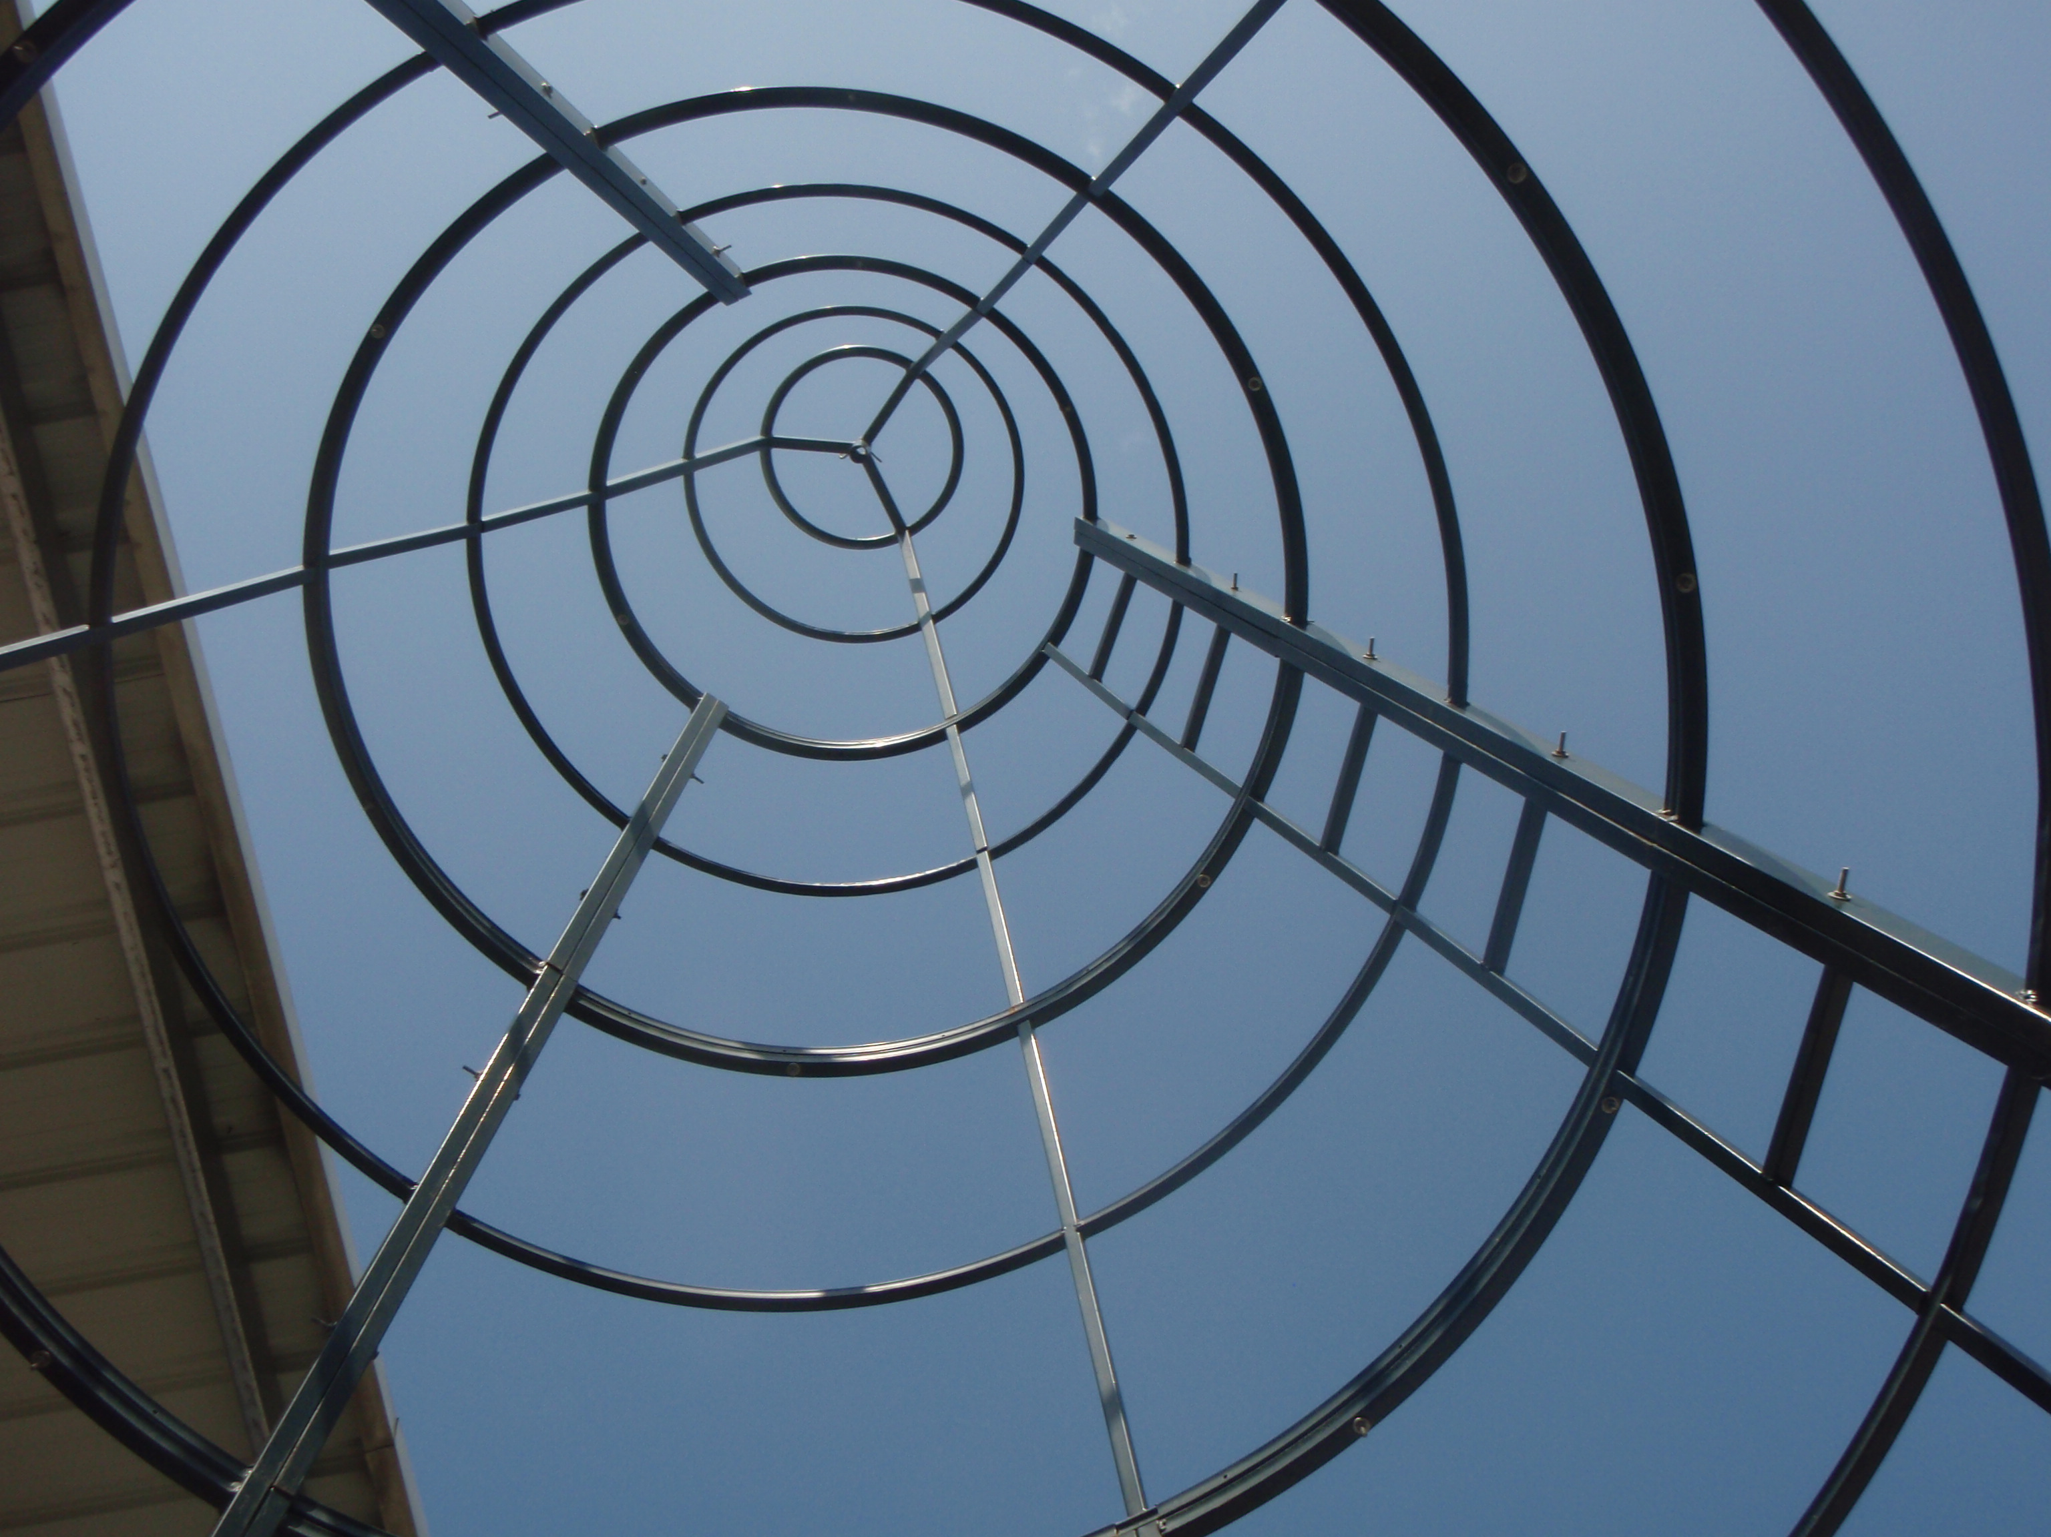

Tree Top
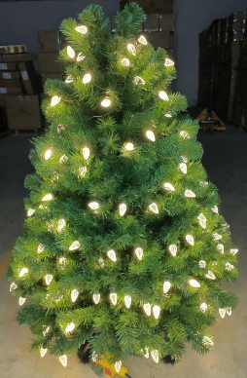
Insert the tree top into the central socket of layer 1

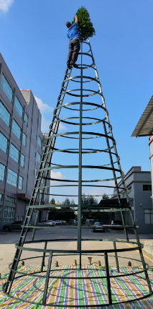
Install the Branch into the hob
