**30" Solar Powered LED Lighted Weathered Red Brick Lighthouse Outdoor Patio Garden Water Fountain**

**ITEM# NORTHLIGHT QK78697**

1. **PARTS**
2. **ASSEMBLY**
3. **MAINTAINENCE**
4. **STORAGE**
5. **PHOTOS FOR YOUR REFERENCE**

**PARTS:**

1. Beacon Tower with Solar Panel - 6.5” High
   1. Two solar panels
   2. On/off switch for beacon
   3. Rotating beacon
   4. Compartment for (1)AA Battery on bottom
2. Lighthouse Tower - 17.75” High
3. Hexagonal Base - 5.75” High
4. Submersible Water Pump - 72” Long Lead Cord
   1. Low Voltage Water Pressure Valve (+/-)

**ASSEMBLY:**

1. Connect the water pump adapter to the hose attached to the tower main frame.

**NOTE: The hose may seem too small for the pump adapter, but it isn’t. The hose can be maneuvered to fit the adapter. This tight seal prevents water leakage and creates better water pressure.**

1. There are indented markers on top of the pump vent indicating + and -. Use the water pump tab to turn the valve in order to adjust your water speed. (+ for faster, - for slower)
2. Use the suction cups of the water pump to attach the pump to the bottom of the hexagonal base.
3. There is a hole at the bottom of your lighthouse tower. Insert the black pole from the base into the hole in the light house tower. The bottom of the lighthouse is completely assembled at this point.
4. Place the beacon tower at the very top of the lighthouse tower. Twist the tower to the left to lock into place.
5. Fill the hexagonal base with water until there is about an inch of space from the top rim.
6. Place the tower in the sun or direct daylight for at least 8 hours.

**NOTE: Lighthouse may not fully charge under cloudy conditions.**

1. Plug the water pump to a power source to start the water circulation after the light house beacon is fully charged.
2. For beacon, use the on/off button which allows you to:
   1. Rotate the beacon with light off
   2. Rotate the beacon with light on
   3. Turn the beacon off

**NOTE: Lights will automatically go on at night and turn off during the day**

**Maintenance:**

1. We recommend cleaning out any debris or foliage that may have entered the base. This can cease the water flow.
2. Clean your beacon tower every so often to give the best shining effect.
3. Clean you solar panels every so often to receive the best solar power.
4. For scum build-up, use a light brush or cloth.

**Storage:**

1. **Note: Be sure to dry light house completely before storing. This prevents augmentation of mold and other outdoor bacteria.**

**Photos:**

**1.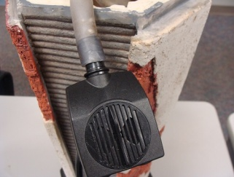 2.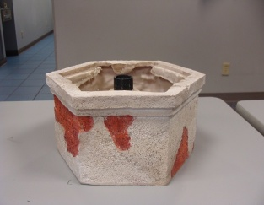 3.**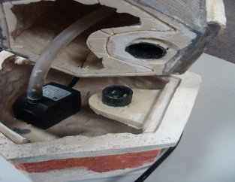

**4. 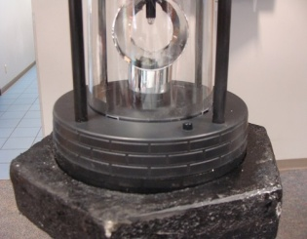 5.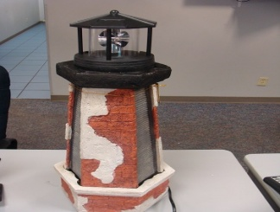 6.**